HOST BEHAVIOR ANALYSIS FOR PROPERTY RENTAL COMPANY

You are an Analyst working for a Property Rental company. The company wants to comprehend how the host behavior varies across a variety of metrics. Company Thus, you are asked to understand the data and come up with the below analysis:

a. Analyze different metrics to draw the distinction between Super Host and Other Hosts:

To achieve this, you can use the following metrics and explore a few yourself.

Acceptance rate, response rate, instant booking, profile picture, identity verified, review scores, average no of bookings per month, etc.

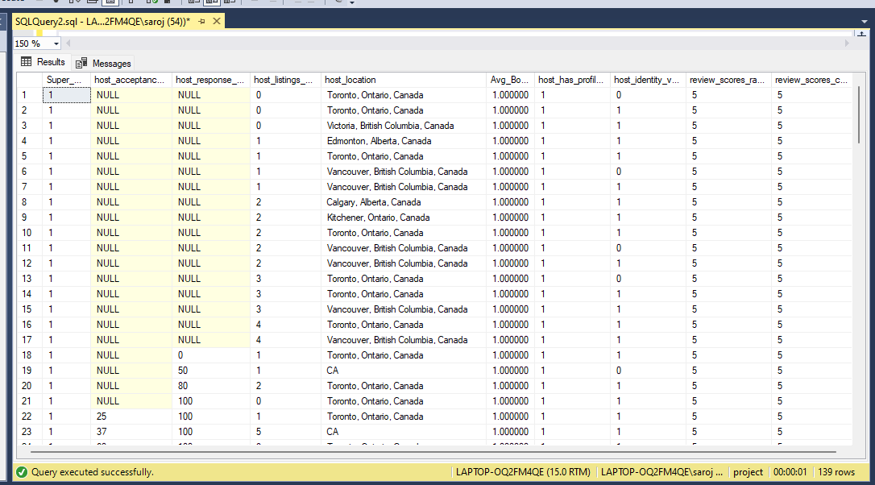**FOR SUPERHOST**

Select * from (select host_is_superhost as Super_Host, host_acceptance_rate,

host_response_rate, host_listings_count , host_location

,AVG(CAST([instant_bookable] as DECIMAL(9,0))) AS Avg_Bookings,

host_has_profile_pic,host_identity_verified ,review_scores_rating,

review_scores_communication from host_vancouver AS hv

inner join listing_vancouver AS lv

on hv.host_id = lv.host_id

where host_is_superhost = '1'

and review_scores_rating = '5'

and review_scores_communication = '5'

and instant_bookable = '1'

group by host_is_superhost, host_acceptance_rate,host_response_rate,

host_has_profile_pic,host_identity_verified ,review_scores_rating,

review_scores_communication , host_location ,host_listings_count)V1

UNION

Select * from

(select host_is_superhost as Super_Host, host_acceptance_rate,host_response_rate,

host_listings_count, host_location

,AVG(CAST([instant_bookable] as DECIMAL(9,0))) AS Avg_Bookings,

host_has_profile_pic,host_identity_verified ,review_scores_rating,

review_scores_communication from host_toronto AS H

inner join listing_toronto AS L

on H.host_id = L.host_id

where host_is_superhost = '1'

and review_scores_rating = '5'

and review_scores_communication = '5'

and instant_bookable = '1'

group by host_is_superhost, host_acceptance_rate,host_response_rate,

host_has_profile_pic,host_identity_verified ,review_scores_rating,

review_scores_communication , host_listings_count , host_location

)T1

**FOR HOST**

Select * from (select host_is_superhost as Host, host_acceptance_rate,

host_response_rate, host_listings_count , host_location

,AVG(CAST([instant_bookable] as DECIMAL(9,0))) AS Avg_Bookings,

host_has_profile_pic,host_identity_verified ,review_scores_rating,

review_scores_communication from host_vancouver AS hv

inner join listing_vancouver AS lv

on hv.host_id = lv.host_id

where host_is_superhost = '0'

and review_scores_rating = '5'

and review_scores_communication = '5'

and instant_bookable = '1'

group by host_is_superhost, host_acceptance_rate,host_response_rate,

host_has_profile_pic,host_identity_verified ,review_scores_rating,

review_scores_communication , host_location ,host_listings_count)V1

UNION

Select * from

(select host_is_superhost as Host, host_acceptance_rate,host_response_rate,

host_listings_count, host_location

,AVG(CAST([instant_bookable] as DECIMAL(9,0))) AS Avg_Bookings,

host_has_profile_pic,host_identity_verified ,review_scores_rating,

review_scores_communication from host_toronto AS H

inner join listing_toronto AS L

on H.host_id = L.host_id

where host_is_superhost = '0'

and review_scores_rating = '5'

and review_scores_communication = '5'

and instant_bookable = '1'

group by host_is_superhost, host_acceptance_rate,host_response_rate,

host_has_profile_pic,host_identity_verified ,review_scores_rating,

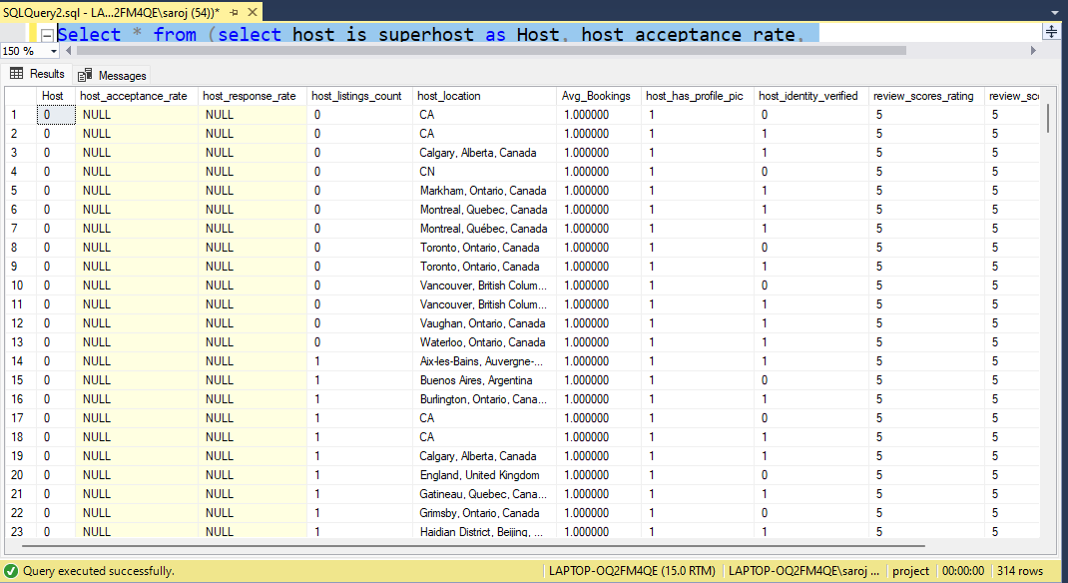review_scores_communication , host_listings_count , host_location)T1

**Combined Query For HOST and SUPER HOST**

Select * , case

when host_is_superhost = '1' then 'Super_Host'

when host_is_superhost = '0' then 'Host' end 'Super_Host_OR_Host '

from (select host_is_superhost , host_acceptance_rate,

host_response_rate, host_listings_count , host_location

,instant_bookable ,host_has_profile_pic,host_identity_verified ,

review_scores_rating,review_scores_communication from

host_vancouver AS hv

inner join listing_vancouver AS lv

on hv.host_id = lv.host_id

where instant_bookable = '1'and host_is_superhost is not null )V1

UNION

Select * , case

when host_is_superhost = '1' then 'Super_Host'

when host_is_superhost = '0' then 'Host' end 'Super_Host_OR_Host '

from (select host_is_superhost , host_acceptance_rate,

host_response_rate, host_listings_count, host_location,instant_bookable ,

host_has_profile_pic,host_identity_verified ,review_scores_rating,

review_scores_communication from host_toronto AS H

inner join listing_toronto AS L

on H.host_id = L.host_id

where instant_bookable = '1' and host_is_superhost is not null )T1

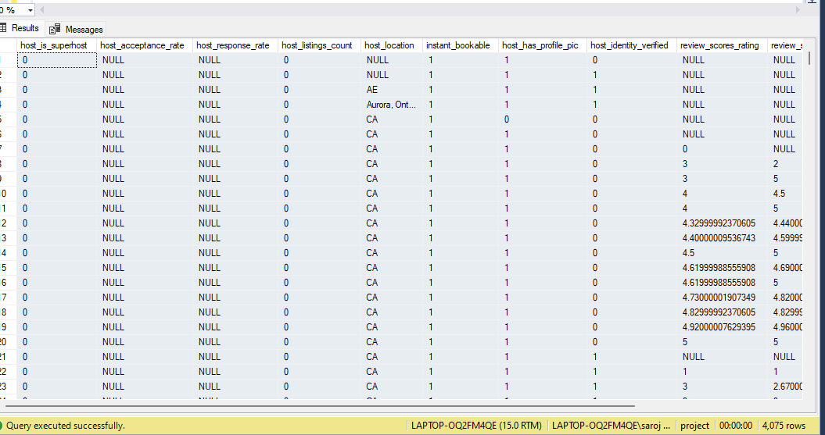

b. Using the above analysis, identify the top 3 crucial metrics one needs to maintain to become a Super Host and also, find their average values.

c. Analyze how do the comments of reviewers vary for listings of Super Hosts vs Other Hosts(Extract words from the comments provided by the reviewers)

Select * , case

when host_is_superhost = '1' then 'Super_Host'

when host_is_superhost = '0' then 'Host' end 'Super_Host_OR_Host ' ,

case

when review_scores_rating >= '4' then 'Good_Ratings'

else 'Bad_Ratings' end 'Ratings'from (select

hv.host_is_superhost , lv.review_scores_rating , rv.comments

from host_vancouver AS hv

inner join listing_vancouver AS lv

on hv.host_id = lv.host_id

inner join review_vancouver AS rv

on lv.id = rv.listing_id

where hv.host_is_superhost is not null ) V1

UNION

Select * , case

when host_is_superhost = '1' then 'Super_Host'

when host_is_superhost = '0' then 'Host' end 'Super_Host_OR_Host '

,case

when review_scores_rating >= '4' then 'Good_Ratings'

else 'Bad_Ratings' end 'Ratings' from

(select ht.host_is_superhost

,lt.review_scores_rating , rt.comments

from host_toronto AS ht

inner join listing_toronto AS lt

on ht.host_id = lt.host_id

inner join review_toronto AS rt

on lt.id = rt.listing_id

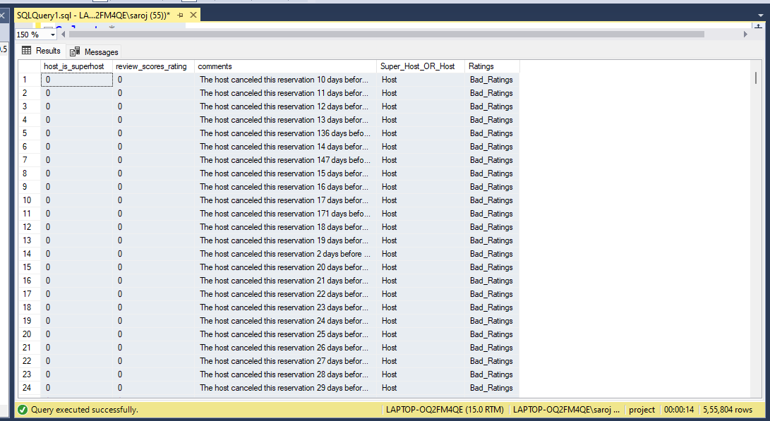where ht.host_is_superhost is not null )T1

d. Analyze do Super Hosts tend to have large property types as compared to Other Hosts

Select * , case

when host_is_superhost = '1' then 'Super_Host'

when host_is_superhost = '0' then 'Host' end 'Super_Host_OR_Host ' ,

case

when room_type IN ('Shared room' , 'Private room') then 'Small_Property'

else 'Large_Property' end 'Properties'from (select

hv.host_is_superhost , lv.room_type

from host_vancouver AS hv

inner join listing_vancouver AS lv

on hv.host_id = lv.host_id

where hv.host_is_superhost is not null

and lv.property_type is not null) V1

UNION

Select * , case when host_is_superhost = '1' then 'Super_Host'

when host_is_superhost = '0' then 'Host' end 'Super_Host_OR_Host ' ,

case

when room_type in ('Shared room','Private room') then 'Small_Property'

else 'Large_Property' end 'Properties'from (select

ht.host_is_superhost , lt.room_type

from host_toronto AS ht

inner join listing_toronto AS lt

on ht.host_id = lt.host_id

where ht.host_is_superhost is not null )T1

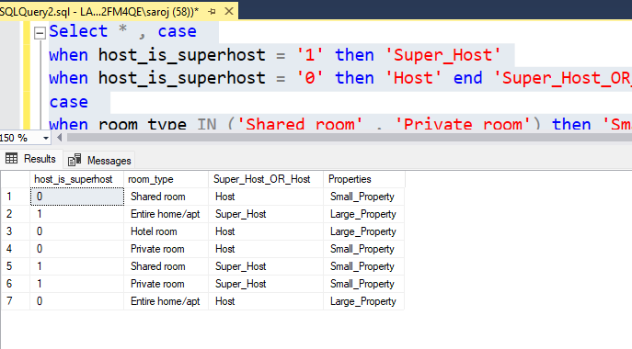

No, the Host has more number large property comparison to the Super host

e. Analyze the average price and availability of the listings for the upcoming year between Super Hosts and Other Hosts

SELECT * , case when host_is_superhost = '1' then 'Super_Host'

when host_is_superhost = '0' then 'Host' end 'Super_Host_OR_Host ' ,

case when available = '1' then 'avail'

when available = '0' then 'not_avail' end 'Availablity'

FROM (select

hv.host_is_superhost , av.date ,av.available, av.price

from host_vancouver AS hv

inner join listing_vancouver AS lv

on hv.host_id = lv.host_id

inner join vancouver_availability AS av

on lv.id = av.listing_id

where year (av.date) > 2022 and

hv.host_is_superhost is not null

and av.available is not null) V1

UNION

SELECT * , case when host_is_superhost = '1' then 'Super_Host'

when host_is_superhost = '0' then 'Host' end 'Super_Host_OR_Host ' ,

case when available = '1' then 'avail'

when available = '0' then 'not_avail' end 'Availablity'

FROM (select

ht.host_is_superhost , at.date ,at.available, at.price

from host_toronto AS ht

inner join listing_toronto AS lt

on ht.host_id = lt.host_id

inner join toronto_availability AS at

on lt.id = at.listing_id

where year (at.date) > 2022 and

ht.host_is_superhost is not null

and at.available is not null) as T1

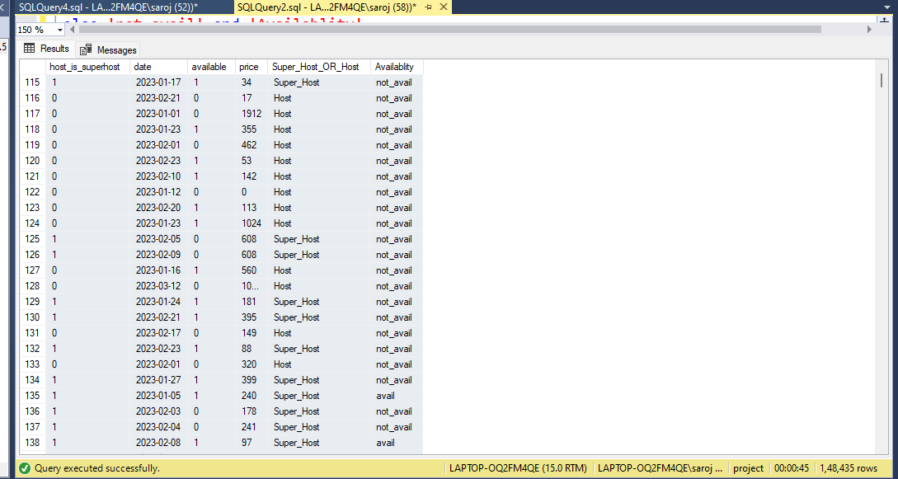

g. Analyze the above trends for the two cities for which data has been provided and provide insights on comparison

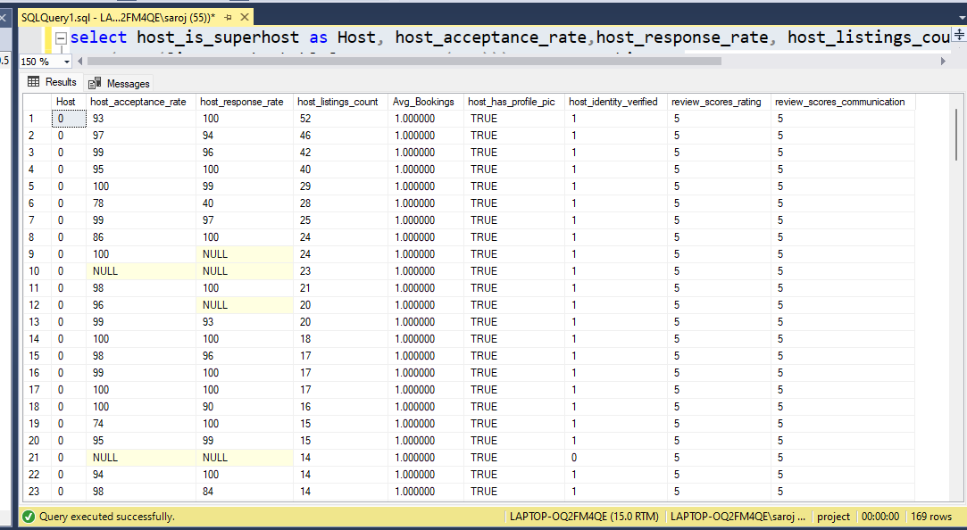**FOR HOST:-**

select host_is_superhost as Host, host_acceptance_rate,host_response_rate, host_listings_count

,AVG(CAST([instant_bookable] as DECIMAL(9,0))) AS Avg_Bookings,

host_has_profile_pic,host_identity_verified ,review_scores_rating,

review_scores_communication from host_toronto AS H

inner join listing_toronto AS L

on H.host_id = L.host_id

where host_is_superhost = '0'

and review_scores_rating = '5'

and review_scores_communication = '5'

and instant_bookable = '1'

group by host_is_superhost, host_acceptance_rate,host_response_rate,

host_has_profile_pic,host_identity_verified ,review_scores_rating,

review_scores_communication , host_listings_count

order by host_listings_count desc

**FOR SUPER HOST:-**

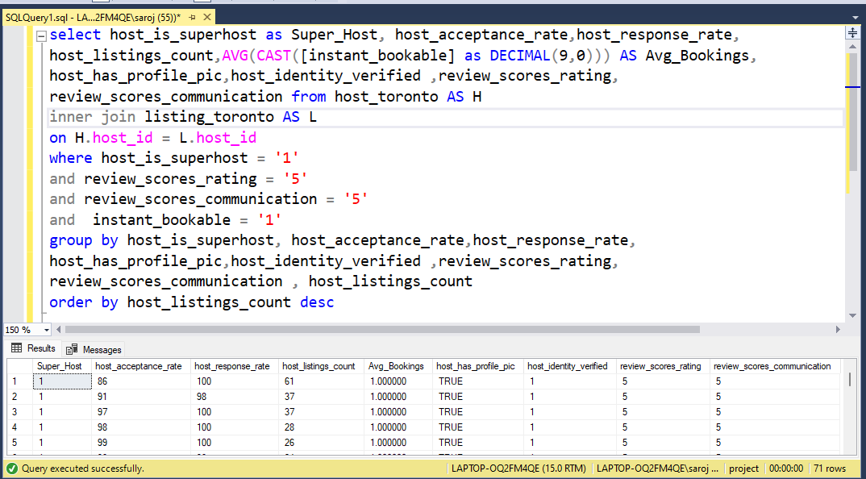

select host_is_superhost as Super_Host, host_acceptance_rate,host_response_rate, host_listings_count

,AVG(CAST([instant_bookable] as DECIMAL(9,0))) AS Avg_Bookings,

host_has_profile_pic,host_identity_verified ,review_scores_rating,

review_scores_communication from host_toronto AS H

inner join listing_toronto AS L

on H.host_id = L.host_id

where host_is_superhost = '1'

and review_scores_rating = '5'

and review_scores_communication = '5'

and instant_bookable = '1'

group by host_is_superhost, host_acceptance_rate,host_response_rate,

host_has_profile_pic,host_identity_verified ,review_scores_rating,

review_scores_communication , host_listings_count

order by host_listings_count desc

Provide your insights in an excel workbook, plot graphs, and create multiple tabs as needed.